Project Report
(Submitted for the Degree of B. Com, Honors in Accounting & Finance under the University of Calcutta)

“IMPACT OF PRIVATISATION OF LIFE INSURANCE CORPORATION OF INDIA ON IT’S CUSTOMERS”

Submitted by
Name of the Candidate: PRIYA SAHA
C U Registration No: 144-1211-0823-20
C U Roll No: 201144-11-0097
College Roll No: BH0386

Supervised by
Name of the Supervisor: Dr. Moumita Sarkar (Samanta)
Name of the college: Bangabasi Morning College

Month & Year of Submission
May, 2023

ACKNOWLEDGEMENT

It is a matter of great pleasure to present this project on IMPACT OF PRIVATISATION OF LIFE INSURANCE CORPORATION OF INDIA ON IT’S CUSTOMERS.
I take this opportunity to thanks our respected principal sir Dr.Amitava dutta for giving me an opportunity to work on this field.
I am very thankful to my supervisor Dr. Moumita sarkar(samanta) for his full support in completing this project work. Finally, I gratefully acknowledge the support of my family/friends and would also like to all the people to whom I had visited during my survey who had given me full support and co-operated with me to carry out this research work and helped me with my project work by filling up the questionnaire/report.

-Priya saha

SUPERVISOR’S CERIFICATE

This is to certify that Miss. Priya saha a student of B.com Honours in Accounting and Finance of ‘Bangabashi morning college’ ‘under the university of Calcutta has worked under my supervision and guidance for his Project Work and prepared a project Report with the title IMPACT OF PRIVATISATION OF LIFE INSURANCE CORPORATION OF INDIA ON IT’S CUSTOMERS which he is submitting is his genuine and original work to the best of my knowledge.

Signature:

Name: Dr. Moumita Sarkar(samanta)
Name of the college: Bangabashi Morning College
Place: Kolkata
Date: 2023

STUDENTS DECLARATION

I hereby declare that the Project Work with the title IMPACT OF PRIVATISATION OF LIFE INSURANCE CORPORATION OF INDIA ON IT’S CUSTOMERS submitted by me for the partial fulfilment of the degree of B.Com Honours in Accounting and Finance under the University/Institution for the fulfilment of the requirement of any course of study.
I also declare that no chapter of this manuscript in whole or in part has been incorporated in this report from any earlier work done by others or by me. However extracts of any literature which has been used for this report has been duly acknowledge providing details of such literature in the reference.

SNATURE:

Name: Priya saha
C.U. Registration no.: 144-1211-0823-20
C.U. Roll No.: 201144-11-0097
College Roll No.: BH0386

CONTENT

CHAPTERS | TOPICS | PAGE NO.
 | Acknowledgement
 | Supervisor’s Certificate
 | Student’s Declaration
CHAPTER-1 INTRODUCTION | Background
 | Justification of the study
 | Brief Review of Literature
 | Objectives of the Study
 | Methodology of the Study
 | Limitations of the Study
 | Chapter Planning
CHAPTER-2 CONCEPTUAL FRAMEWORK | Concepts/Different  terminologies
National Scenario
International Scenario
CHAPTER-3 PRESENTATION AND DATA ANALYSIS | Presentation of Data,  Application of Statistical Tool and Interpretation
 | Findings
CHAPTER-4 CONCLUSION AND  RECOMMENDATIONS | Conclusion
 | Recommendations
 | Bibliography /References
 | Annexure :
Questionnaire
Annual Reports

Chapter - 1

BODY OF PROJECT
- Introduction

  - Background of the Study Topic
The study seeks to ravel the privatization of insurance sector in Indian scenario and Also drafted the pros and cons of this conglomerate to evaluate the insurance on health, and a one set go process of the protection from financial loss.
Privatization is the process of transferring ownership of a business, enterprise, agency, public service or public property from the public sector (a government) to the private sector, either to a business that operate for a profit or to a non-profit organization insurance in India refers to the market for insurance in India which covers both the public and private sector organizations. We will discuss about the impact of Privatization of LIC. Is it suitable for insurance sector or not?
What will be the result of Privatization of wholly government owned organization and highest GDP generating sector? It is also to be clarified that the changes will occur in GDP rate due to Privatization. Private enterprise should be more responsive to customer complaints and innovation. The government should not be a player and an umpire, and it should lead to lower prices and greater supply.
Competition in privatization increases differentiation.
We will come to know regarding the boons and banes of this privatizations of LIC in the forthcoming chapters.

  - Rational/need/justification of the study topic
The huge and ever rising population levels in our country provide an attractive opportunity but still nearly 70% Indian lives is un-insured. Though in nowadays more customers are aware about the importance of Life insurance in their life and mostly to their family. Hence it became the most GDP generating sector of India. Insurance has always been a politically sensitive subject in India. After 40 years of government protectionism of this massive sector, the government is touching dangerous yet interesting ground with their intentions of opening this sector to private Indian business houses, as well as international player. This project is decked up on the topic of “Privatisation of LIC”.

  - Brief Review of Literature of the Study Topic
Tapas Kumar Parida, (2014) – The need of FDI hike in insurance sector has been studied and
Compared. The real assessment of FDI requirement in Indian Insurance Sector with economic
View has been studied. After opening of insurance sector for private companies, the public
Sector monopoly has come to an end.

Yogesh Jain, (2013) – Studied economic reforms in India by 1991 and world economic crisis
In 2008-09. And its impact on life insurance sector has been studied. After opening up
Economic crisis, Indian life insurance developed with constant growth rate.
Yogita Sharma, (2013) – The SWOT analysis i.e. “Strength and weakness” and
“Opportunities and threats” in insurance sector in India has been studied. There is huge
Potential for growth in insurance sector in India, exceptionally low penetration of insurance is a
Big Concern as well as it is big opportunities also.
Rashmita Sahoo, (2012) – analyzed Indian Life insurance market. More than 80% of the
Population in India does not have any life insurance cover. There was monopoly of LIC. But
After privatization and opening of life insurance sector, this sector is developing amazingly fast
The growth rate of life insurance industry in India is @ 15 to 20% per annum.
Megginson and Netter (2001) – document that Privatisation as a political, social, and economic
Policy can be taken to mean “the deliberate sale by a government of state-owned enterprises
(SOEs).

  - Objectives of the Study Topic
The objective of present study is to examine the impact of liberalization On life insurance business in India. In addition to this general objective, The following are the specific objectives of the study:
1.To finding the pros and cons of privatization in insurance sector.
2. To know the level of satisfaction of the consumers by the both sectors.
3. To evaluate preferences of the customers while taking life insurance investment decision.
4. Creating awareness in the mind of the public about the need for life insurance.
5. To evaluate the growth of LIC during the period of the study.
6. To study and analyse the impact of various demographic factors on customers life insurance investment decision.
7. To evaluate the impact of privatisation of LICI on it’s policy holders.

  - Methodology of the Study:
  - Area of the Study Topic
174, Prafulla nagarbelghoria and beside Bangabasi Morning College
  - Sample
50

  - Type of the Study
This study is based on two types of data.
    - Primary type of data
    - Secondary type of data
The data which is collected are fresh and first-hand and for first time and is original in nature called
Primary data. Primary data are generally collected through interviews, applying questionnaire Method, attending seminars, conferences etc.
The data which are collected from books, journals, records, annual reports, and print out from
Website are known as secondary data.
  - Tools for Data Collection
Tool mainly used for primary data collection is questionnaire.
Tools used for secondary data collections are websites, annual reports, books etc.
  - Method of Analysis
Here we go through the two types of data analysing methods. Those are – quantitative such as
Statistical measurements which we earned from secondary data and qualitative such as collecting
Consumers’ review on this matter through questionnaire.

  - Limitations of the Study
Since efforts have been taken to collect necessary and relevant data. Every project has some limitations which create barriers to the step to completion. I have facedProblems at the time of collecting data or information’s. The data has been collected in two way
Those are – 1. Quantitative method and 2. Qualitative method. In both cases there are few
Limitations. The limitations so experienced are stated below: -
Quantitative Method –

- Related secondary data is sometimes not available or accessing available data isDifficult/impossible.
- Difficult to understand context of a phenomenon.
- Data may not be robust enough to explain complex issues.
- The trend of premium growth rata and policy holders’ rate for a period could not be revealedBecause of the non-availability of data during many years.

Qualitative Method –
- Findings usually cannot be generalised to the study population or community.
- More difficult to analyse; do not fit neatly in standard categories.
- Data collection is usually time consuming.
- Particularly collection primary data is problematic due to its confidentiality.

Chapter planning:
Keeping in mind the objective of the project work, the work has been divided into many chapters as it makes a transparent concept of the Privatization of life insurance Corporation of India on the economy as well as in the life of consumers. Chapter planning is most important part of any project to implement its meaning in most favorable way, without chapter planning it is too hard to implement the main objectives to the consumers as they become aware of this pros and cons of that project topic. These chapters are as follows –

INTRODUCTION

    - BACKGROUND OF THE STUDY
    - RATIONAL / NEED/ JUSTIFICATION OF THE STUDY TOPIC
    - BRIEF REVIEW OF LITERATURE OF THE STUDY TOPIC
    - OBJECTIVE OF THE STUDY TOPIC
    - METHODOLOGY OF THE STUDY TOPIC-
      - AREA OF THE STUDY TOPIC
      - SAMPLE
      - TYPE OF THE STUDY
      - TOOLS FOR DATA COLLECTION
      - METHOD OF ANALYSIS

    - LIMITATIONS OF THE STUDY
    - CHAPTER/ PARAMETER PLANNING FOR ACHIEVING THE OBJECTIVES

Conceptual Framework / National / International Scenario
- Short Description of Terminologies used in the Study
- National Scenario of the Study Topic
- International Scenario of the Study Topic

Presentation of Data, Analysis and Findings
- Tabular Presentation of Numerical Data Parameter wise
- Diagrammatic Presentation of Numerical Data Parameter wise
- Analysis Parameter wise
- Writing of Findings of all Parameters in single place

Conclusion and Recommendations
- Writing Main Findings in Short Language i.e. Concluding Observations
- Recommendations / Suggestions for further development of the Study Topic

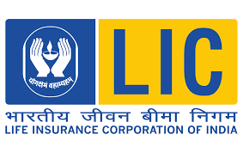

CHAPTER-2
- Conceptual Framework / National / International Scenario
The British companies started life insurance business in India, by issuing Policies exclusively
On the lives of European soldiers and civilians. Different insurance companies like Bombay
Insurance Company Ltd. (1793) and Orient Life Assurance Company (1818) was formed to
Issue life assurances Policies in India. Gradually the first Indian Company named as Bombay
Mutual Life Insurance Society Ltd. The act was amended in 1950 resulting in fat reaching
Changes in the insurance sector. By 1956, 154 Indian insurers, 16 foreign insurers and 75
Provident societies were carrying on life insurance business in India, then it was taken over by
Government of India. Life Insurance Corporation of India (abbreviated as LIC) is an Indian
State-owned insurance group and investment corporation owned by the Government of India.
The Life insurance Corporation of India was founded on September 1, 1956 with a capital
Contribution of Rs 50 when the Parliament of India passed the Life Insurance of India Act that
Nationalized the insurance industry in India. Over 245 insurance companies and provident
Societies were merged to create the state-owned Life Insurance Corporation of India.
Policies offered by LIC: -
- Insurance Plans
  - LIC’s SINGLE PREMIUM ENDOWMENT PLAN
  - LIC’s JEEVAN LABH
  - LIC’s JEEVAN UMANG
  - LIC’s BIMA SHREE POLICY DOCUMENT

2. Health Plans
a. LIC’s JEEVAN AROGYA
b. LIC’s CANCER COVER
3. Pension Plans
  - PRADHAN MANTRI VAYA VANDANA YOJANA
  - LIC’s JEEVAN SHANTI
4.Special Plans
a.LIC’s NEW JEEVAN MANGAL
b.MICRO – INSURANCE FORMS
c.LIC’s BHAGYA LAKSHMI

- Unit Plans
  - LIC’s SIIP
  - LIC’s NIVESH PLUS

- Micro Insurance Plans

- Withdrawn Plans
  - LIC’s JEEVAN RAKSHAK
  - LIC’s JEEVAN SHANTI

National Scenario of the Study Topic
Indian economy is in transition over the last ten years, owing to the initiation of major economic
Reforms affecting almost all sectors. The paradigm shifts from a mixed economic organization to
A market –oriented organization has exposed all sectors to an intense competition, INSURANCE
Business is the most significant one among them. Insurance is an attractive option for investment.
While most people recognize the risk hedging and tax saving potential of insurance, many are not
Aware of the advantages as an investment option as well. The life insurance industry in India is
Regulated by the Insurance Regulatory and Development Authority (IRDA). Twenty-four Life
Insurance companies are licensed to do Insurance Business in India. Out of these companies, Life
Insurance Corporation of India (LIC of India) is the only public sector company.
Since opening of the market and constitution of IRDA in 1999, the number of private players has

Increased with time and has reached 24 as of 2019. But Still LIC of India the only public sector
Insurer is dominating the market with 66.24% of market share in premium.
National insurer Life Insurance Corporation of India (LIC) is completing 63 years of its
Incorporation.
Having begun its journey on September 1, 1956, with an initial capital of Rs 5 crore and an asset
Base of Rs 352.20 crore, LIC today has assets of over Rs 28.45 trillion with life fund to the tune of
Rs 25.84 trillion. From 168 offices in 1956, it today has over 4,826 offices, 1.11 lakh employees,
11.48 lakh agents and 29 crores plus police in force.
With such an asset base, LIC is the biggest financial institution in the country today. LIC of India,
The only public sector company leads the market with 66.24% share in premium and 74.71% in the
Number of polices.

2.3 International Scenario of the Study Topic
LIC is present in 14 countries through branch offices, wholly owned subsidiaries and joint ventures
in Fiji, Mauritius, England, Bahrain, Nepal, Sri Lanka, Singapore, and Bangladesh, among others.
LIC Fiji -
LIC has been operating in Fiji for over 60 years and is today one of the leading insurers in Fiji
with an asset base of over F$ 500 million.
Products offered: -
1. personal insurance
2. micro insurance
3. group insurance
4.Rider options
5.Withdrawn plans

LIC Mauritius –
The Mauritius Branch of Life Insurance Corporation of India was formed alongside its formation
In India in 1956 and has a major share of the life insurance business on the island. It was the first

Insurance company to commence grant of life insurance protection to the citizens in Rodrigues.
There are several unique features that set LIC Mauritius apart from other insurance companies:
LIC Mauritius is small enough to give personalised attention to every customer but, at the same
Time, with the global portfolio, big enough to tower over all other companies put together.
All the polices issued by the LIC Mauritius are guaranteed by the Government of India.
LIC brings to Mauritius a high-quality governance, generates stable returns, and contributes to the
Country’s economy with increasing tax payments.

LIC UK – Life Insurance Corporation of India has a worldwide presence. As part of its worldwide
Operations, the UK branch was established in 1961 in London. LIC UK provides information and
Advice on the Protection, Pensions, Savings and Investment products and services from its own
Range of products and carefully selected third party products. LIC UK is the trading name of Liow
Insurance Corporation of India. It is authorised and regulated by the Financial Services Authority.
LIC UK is a branch of Life Insurance Corporation India. LIC UK and is committed to provide
Customers in the UK with competitive products and services. With knowledge of the UK and the
Indian markets, LIC state they are well-placed to deal with customers in the UK as well as those
From India living in the UK on a temporary basis.
LIC UK has a choice of traditional with profit plans and unit linked plans.
- Bonus builder saving plan
- High start bonus builder saving plan
- Special high start bonus builder saving plan
LIC Bahrain –
LIC (International) BSC © came into existence on the 23rd of July 1989 in the Kingdom of
Bahrain in partnership with International Agencies Co. Ltd. (Intercom), with the objective of
providing life insurance cover to the Indian Diaspora in GCC countries. The journey of LIC
(International) BSC (C) in the past 29 years is an exemplary story of sharing and fulfilling dreams
and prosperity of thousands of NRIs. The Company operates in 4 GCC countries: Bahrain, UAE
(Dubai and Abu Dhabi), Kuwait and Oman. Starting its operations with USD 0.245 million of
asset base, it has grown to more than a Billion-Dollar company today. With the market share of
45.85% and 89.98% in premium income and Policies respectively as at 31st of December 2016
(Source – CBB Insurance Market Review 2016), the Company has been the market leader in life
insurance / long-term business in Kingdom of Bahrain for past many years.
LIC Nepal -
Life Insurance Corporation Nepal Limited (shortly called as L.I.C. Nepal) is one of the largest
capitalized insurance companies of Nepal. The journey of L.I.C. Nepal had its genesis in 2000
when global insurance behemoth, Life Insurance Corporation of India, joined hands with Vishal
Group, a dominant player of Nepal. 55% of ownership of the Company is held by L.I.C. of India,
25% by Vishal Group and 20% by public in the form of equity. This way the essence of L.I.C.
Nepal can best be described by the word "Global" i.e. a unique combination of global experience
with local expertise.
LIC Sri-Lanka -
LIC (Lanka) Ltd. is a joint venture of LIC India, a global giant in providing life insurance, and the
Bartleet Group of Companies, one of the leading financial conglomerates in Sri Lanka with
diversified interest in Financial Services, Information Technology, Money brokering and Stock
Brokering (Lanka) Ltd. has completed more than 15 years in Sri Lanka, and has 30 branches across
the Island and has the vision to “ emerge as the premier provider of Life Insurance in Sri Lanka”.
LIC Singapore –
Incorporated as a direct life insurer in Singapore in 2013, we are a fully owned subsidiary of the
LIC of India. Established in 1956, LIC is owned by the Government of India. It is one of the largest
insurance companies in the world with over 300 million policies in force and over USD 400 billion
in assets.
Products offered
- LICs Grow smart endowment plan
- LICs wealth plus v endowment plan
- Direct – LICs new secure future term plan
- LICs new secure future term plan

LIC Bangladesh –
It is a new entrant in life Insurance Industry of Bangladesh. Insurance Development and
Regulatory Authority has approved the license on 20.12….. LIC shall played a significant role in
Spreading life insurance among the masses and mobilization of people’s money for people’s
Welfare.

Products offered –
- NaboJibonAnando Plan
- JibonRakkhak Plan
- Single Premium Endowment Plan
- New Money Back Plan (20years)
- New Money Back Plan (25 years)
- Group Insurance Plan
- LIC’s BIMA Diamond
- LIC’Ss Young Citizen (education policy foe child)
- LIC’s Pension Plan
- LIC’s Grow Fast

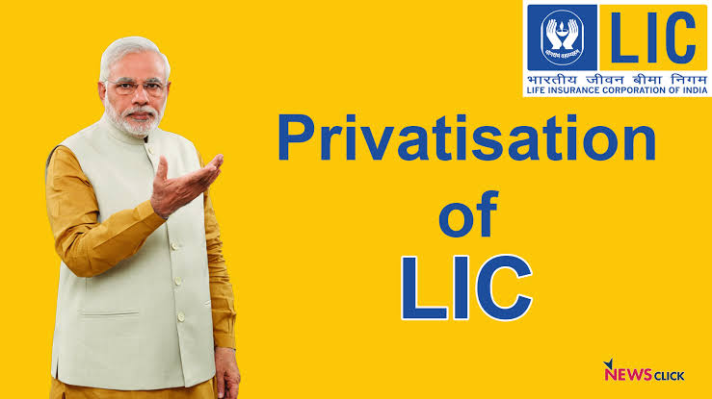

CHAPTER – 4
CONCLUSION AND RECOMMENDATION

Chapter -5

Bibliography :-

- WEBSITES:

- www.wishpolicy.com

- www.m.economictimes.com

- www.bimabazar.com

- www.licindia.in

- REPORTS:

- Annual report of LICI

- Business

- Times of India

CHAPTER – 3
PRESENTATION AND DATA ANALYSIS
Presentation of data, graphical representations and interpretations.
The process of extracting, compiling and modelling raw data for the purpose of obtaining constructive information that can be applied to formulate conclusions, predicting outcomes or supporting decisions in business is called data analysis.
My project is mainly based on secondary data about the awareness of IMPACT OF PRIVATISATION OF LIFE INSURANCE CORPORATION OF INDIA ON IT’S CUSTOMERS , but I also did a primary survey on how many people are actually aware of IMPACT OF PRIVATISATION OF LIFE INSURANCE CORPORATION OF INDIA ON IT’S CUSTOMERS.
Data from various sources is gathered, reviewed and then analysed to form some sort of finding or conclusion. Here is the result on the basis of respondent’s data.
Q. Gender
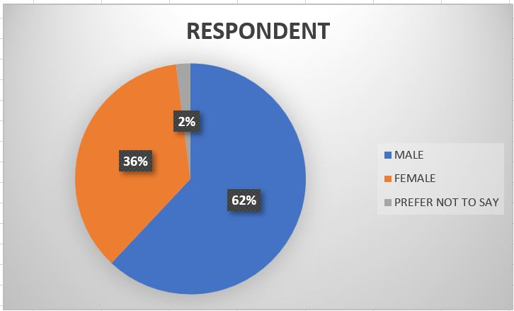
Q. Do you have life insurance policy with LIC?

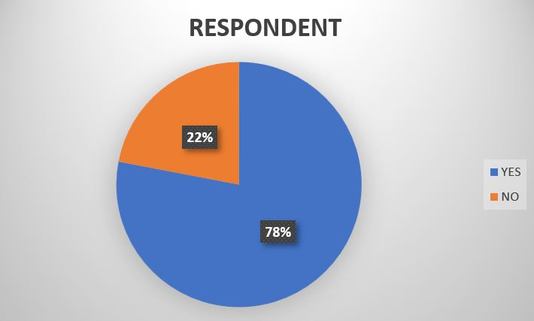

Q. What kind of insurance policy do you have?
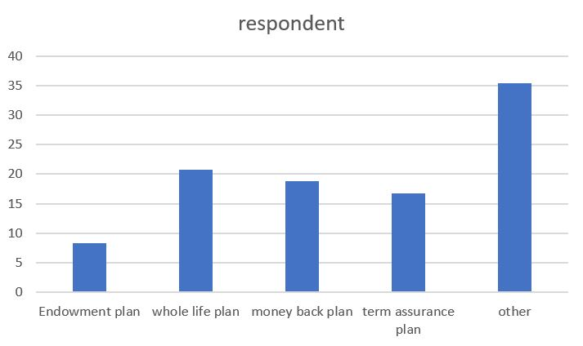
Q. For what reason you have insured yourself?
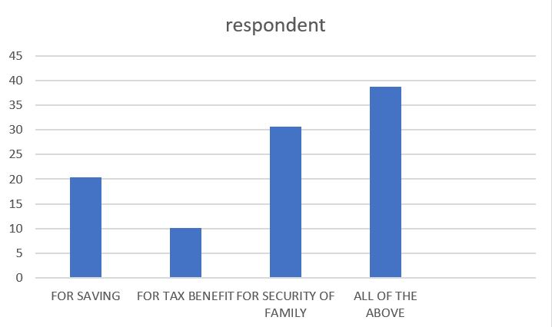
Q. Does Life Insurance Corporation follows the rules of IRDA?
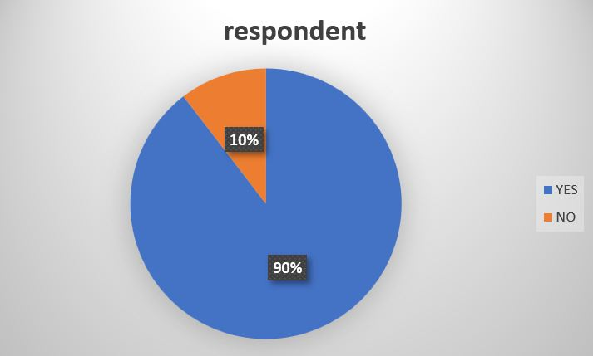

Q. What changes will occur in GDP of the country through privatisation of LICI?
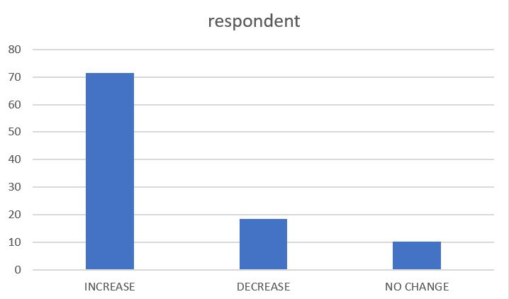
Q. Will privatisation of life Insurance Corporation of India results in customer dissatisfaction?
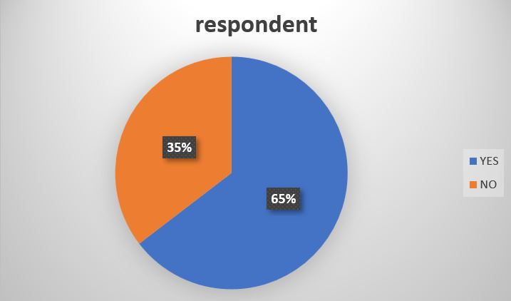
Q. Will the total investment in policies enlarge due to privatisation?
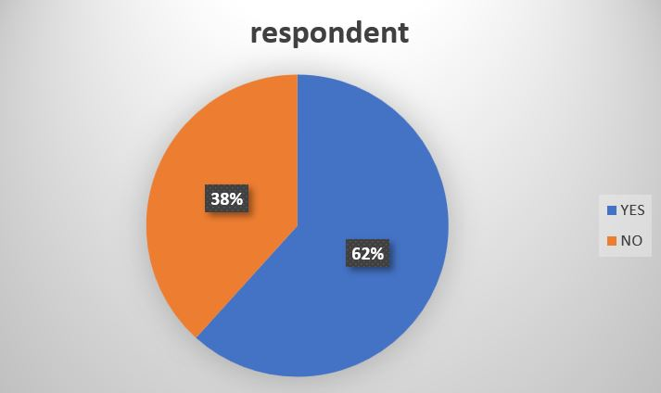

QUESTIONNAIRE
1. Name
---------------
2. Age
----------------
3. What is your occupation?
a) Student
b) Employed
c) Business
d) Profession
e) House wife/retired/unemployed
4. Gender
a) Male
b) Female
c) Prefer not to say
5. Do you have a life insurance policy?
a) Yes
b) No
6. Do you have a life insurance policy with LIC?
a) yes
b) no
7. What kind of insurance policy do you have?
a) Endowment
b) Plan Whole life
c) plan Money back
d) plan Term assurance plan
e) Other

8. Who influenced you to get an insurance policy?
a) Media
b) Insurance agent
c) Friend's
d) Family
9. For what kind of insurance policy do you have?
a) Endowment plan
b) Whole life plan
c) Money back plan
d) Term assurance plan
e) Rider
f) Other
10. for what reason you have insured yourself?
a) For saving
b) For tax benefit
c) For security of family
d) All the above
11. How would you like to pay premium?
a) Monthly
b) Quarterly
c) Half yearly
d) Yearly
12. Have you ever received any benefit for any of the policies you currently have?
a) Yes
b) No
13. Does Life Insurance Corporation follows the rules of IRDA?
a) Yes
b) No

14. What changes will occur in GDP of the country through privatisation of LICI?
a) Increase
b) Decrease
c) No change
15. Will privatisation of life insurance Corporation of India results in customer dissatisfaction?
a) Yes
b) No
16. Will the total investment in policies enlarge due to privatisation?
a) Yes
b) No
17. If total investment in policies enlarge due to privatisation then what are the features enhancing the total investment in policies?
a) Faith on private organisation
b) Assurance of higher plan
c) Efficient customer service
d) Others

